CSCI 5722 Computer Vision, Spring 2020

Student: Yinbo Chen

Instructor: Fleming

Homework 3

**Q1. True or False? Explain your reasoning. If the zero vector is part of a set of vectors, then that set is linearly dependent.**

It’s true. To assume that v is a vector space and consider **{0, v1,v2 , … ,vn} vi∈v.**To examine**c0*0 + c1*v1 + c2*v2 +…+ cn*vn = 0**.Let**c0 = 1** and**c1 = c2 = c3 … cn = 0**.So the equation can be expressed as**1*0 + 0 * v1 + 0 *v2 + 0 * v3 + … +0 * vn = 0**. It shows that there exists**ci’**s not all zero and still satisfy the equation.

**Q2. True or False? Explain your reasoning. If a set of vectors is linearly dependent so is any larger set which contain it.**

It’s true. To assume that **p** is a vector space and consider**{p1,p2,p3,…,pn} pi ∈p**is dependent. And there are coefficients**a1, a2, … an,**are not all zero. The equation can be expressed as

**a1p1 + a2p2 + … + anpn= 0**

Now let **q** is **p’s** larger set and **m>= n**, and consider {**p1, p2, p3, …, pn** ,**pn+1, pn+2, … , pm**}. The equation of **q** can be expressed as

**b1p1 + b2p2 + … + bnpn+ bn+1pn+1 + bn+2pn+2 + … + bmpm = 0**

Take **b1 = a1, b2 = a2, … ,bn = an**, and **bn+1= bn+2 = … = bm = 0**. Because**ai’**s are not all zero, **bi**’sare not all zero either. We got the equations

**b1p1 + b2p2 + … + bmpm =a1p1 + a2p2 + … + anpn= 0**

So {**p1, p2, …, pm**} is linearly dependent as well.

**Q3. Show that convolving an image with a discrete, separable 2D filter kernel is equivalent to convolving with two 1D filter kernels. Estimate the number of operations saved for an N*N image and a (2k + 1) * (2k + 1) kernel.**

Let y[m,n] as the output image and x[m,n] is an input image. h[m,n] is a 2D filter. The 2D convolution is expressed below,

Y [m, n] = x [m, n] * h [m, n]

The 2D filter can be decomposed into two 1D filters. The equation is:

h [m, n] = h1 [m] * h2 [n]

So the final equation can be expressed as:

Y [m, n] = x [m, n] * h1 [m] * h2 [n]

As well as

Y [m, n] = x [m, n] * h2 [n]* h1 [m]

For example, in convolution a 2D filter with M*N kernel. To assume if the kernel size is 3 * 3 and it can be decomposed into (M *1) and (1 * N) matrices as below:

=

So convolution with this separable kernel is equivalent to:

x[m, n] * = x[m, n] *

Number of operations saved:

Using a 2D filter convolves an N x N image with a (2k+1) x (2k+1) kernel. It totally needs N2(2k+1)2 operations. But performing two 1D filters only needs N2(2(2k+1)). Let **i** equal to the saved operations, then:

i= N2 (2k+1)2 - N2(2(2k+1)) = N2(4k2 + 4k +1 -4K -2) =N2(4k2 - 1)

**Q4. What happens when we convolve a Gaussian with another Gaussian? Explain.**

We will get a wider Gaussian. The variance equals to the sum of two original variances. Consider that we have two Gaussiansf1 and f2:

=

**Q5. What is Dimensionality Reduction and how is it important with respect to Image Processing? Elaborate on at least one advantage and one disadvantage.**

Dimensionality Reduction is the process of reducing the number of features which is the way to reduce the complexity of a model. It can be used in data analysis and it’s very important in image processing. For example, the most popular linear dimension reduction is Principal Component Analysis (PCA) which transfers the data from the high dimension space coordinate system to a low space coordinate system. Using this method can significantly retrieve the main features or key points from a new system, such as using Scale-Invariant Features Transform (SIFT) which shows scaling the space to several lower dimension spaces and find the invariant points.

The advantage of using Dimensionality Reduction: it reduces the consumption of resources such as memory space and computational time.

The disadvantage of using Dimensionality Reduction: it might lose some crucial details and sometimes, it’s fatal. For example, in an auto-pilot field, real-time computation with a small time lag is necessary. Most of the time, Dimensionality Reduction fits this position very well, but in some situations, some critical features are reduced or be recognized as different objects that can cause serious results due to some special weather conditions and it’s fearful.

**Q6. Show that for a 2*2 matrix A , with eigenvalues λ1, λ2**

1. **det(A) = λ1 * λ2**

Because eigenvalues are roots of the characteristic polynomial p(**λ**) = det(A –**λІn**). We have:

det(A –**λІn**) = =

In our situation, A is a 2 x 2 matrix, so n =2 ,det(A –**λІ2**) = . Let = 0, we have:

det(A ) = =**λ1 * λ2.**

1. **trace(A) =λ1 +λ2**

According to above equation, we compare the coefficients of **λn-1**of both sides.

The coefficient of **λn-1** of the determinant on the left side of the equation, we have:

() =

The coefficient of **λn-1**of the determinant on the right side of the equation, we have:

In our situation, n =2. The equation is:

= = -(**λ1+λ2)**

=**λ1+λ2**

**Q7.A rigid – body motion is a family of transformations that preserve the shape and size of objects. In general, any proper rigid- body transformation can be decomposed as a rotation followed by a transformation. Show that, for any two vectors u, v R3 :**

1. **A rigid- body transformation g: R3 R3 preserves the norm of the vectors:**
2. **A rigid – body transformation g: R3 R3 preserves the cross product of two vectors:**

**(g * u )*(g * v) = g* (u * v)**

**Q8. Design and implement a way of verifying experimentally that repeatedly applying an averaging filter approximates Gaussian smoothing. Note: this problem will require you to explain you design in writing, then implement it and test it via Matlab.**

**Q9.Matlab programming:**

**Part A:**

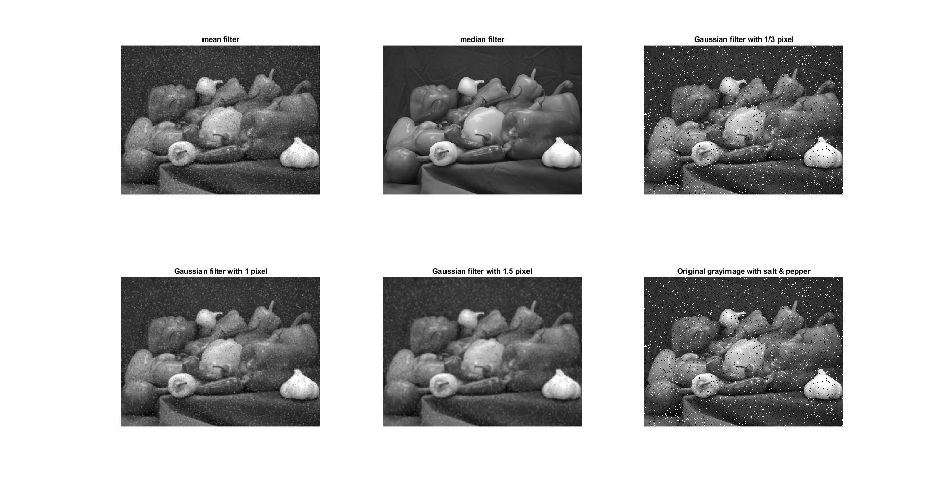

These images were performed by adding “salt & pepper” noise then applied five different filters on them. The image in the bottom right corner is the original picture without filtering, only added noise. To compare the results of these images. I found that the image with a median filter has the best result which hardly to see any noise at all. The worst result comes from a Gaussian filter with 1/3 pixel. Instead of disappearing, the noise tends to sharpen. The results from the mean filter and the Gaussian filter with 1 pixel are similar. The image was operated by the Gaussian filter with 1.5 pixels which can see the result as same as the mean filter’s and the Gaussian filter with 1 pixel’s, but the noise is blurred a little bit.

**Part B:**

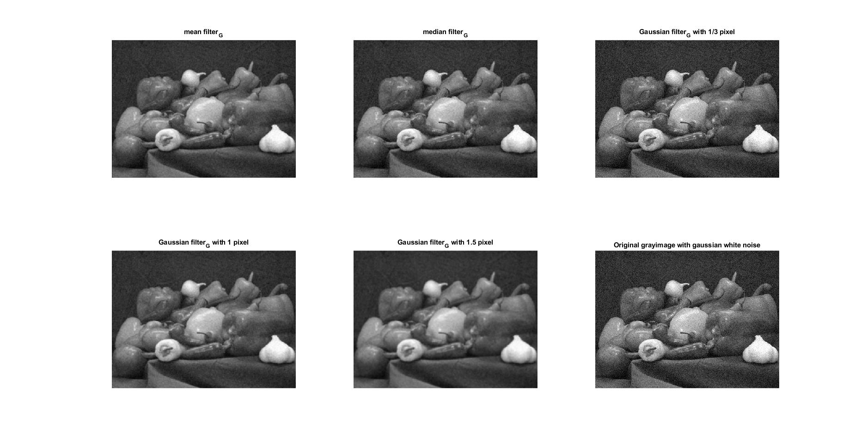

These images were performed by adding Gaussian white noise with mean 0 and in the [0,1] range then applied five different filters on them. The image in the bottom right corner is the original picture without filtering, only added noise. To compare the results of these images. I found that all results are similar that we can see the noise clearly. The worse result comes from the Gaussian filter with 1/3 pixel which is similar to original image without filtering. The image performed by a Gaussian filter with 1.5 pixels is blurred, and the three remaining images are the same.

**Q10.Matlab programming: write your own implements of the Harris Corner Detector algorithm.**

**Part A:**

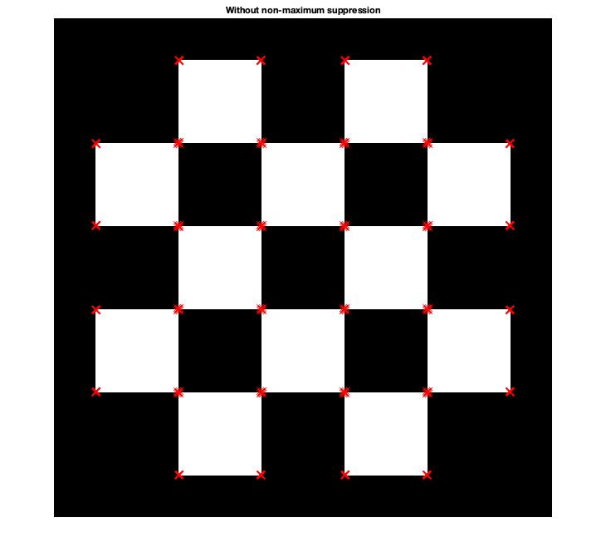

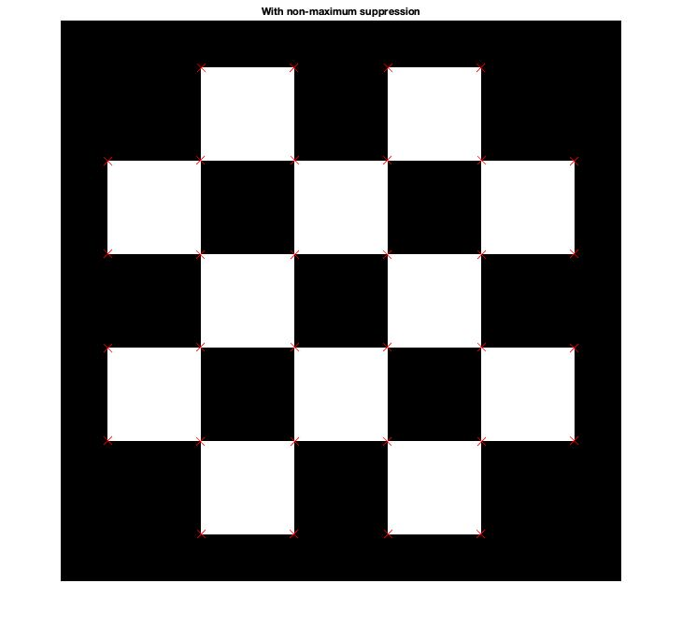

**Part B:**

All results in this section under the same parameters’ condition. The variables values are:

Threshold = 100; w = 3 and suppression = true.

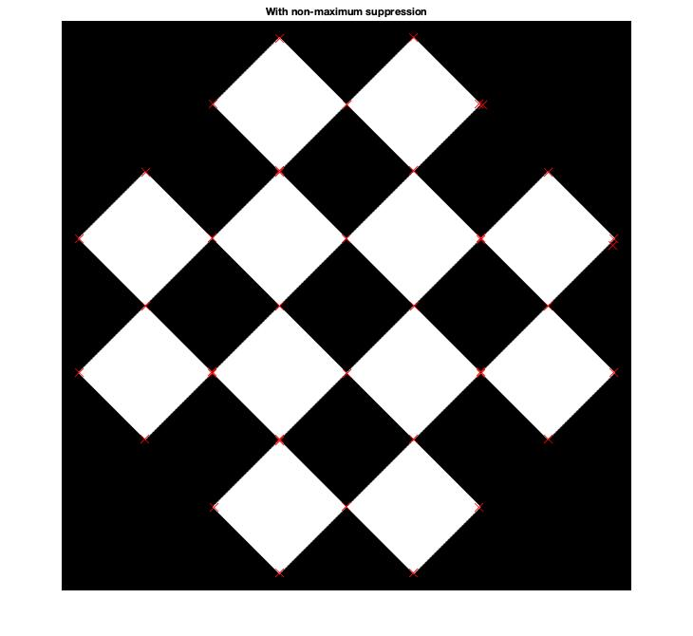

The first image is the original image. Corner detector detected all corners. The second image is the original image that made a 45-degree clockwise rotation. The results are similar. Corner detector detected all corners in both images.

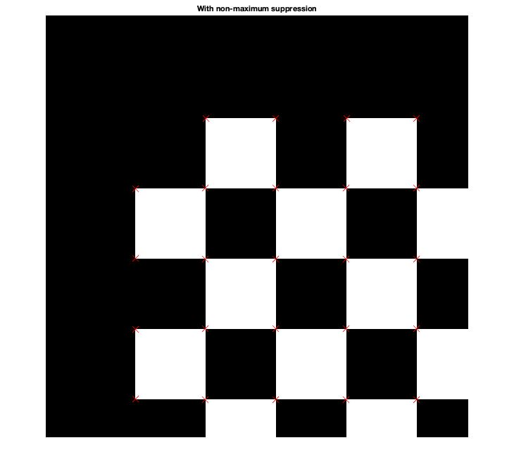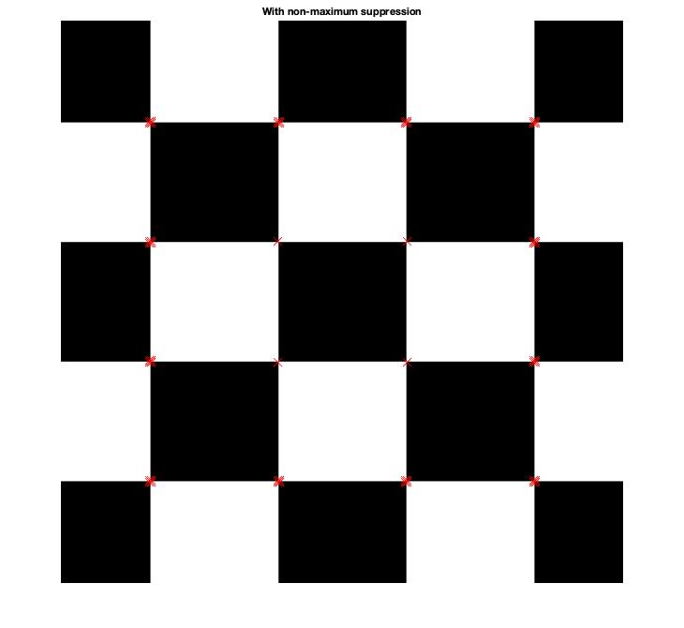

These two images are translatedand scaled versions. In the translated image, all corners are detected except the corners at the edge of the picture. This phenomenon also exists in the scaled version. In the scaled image, the corner detector missed the corners at the edge and marked multiple detections of all corners. It might be caused by the threshold’s value and w’s value. I experimented to increase w’s value from 3 to 7 and keep the threshold’s value the same. It succeeded in detection. The result shows below:

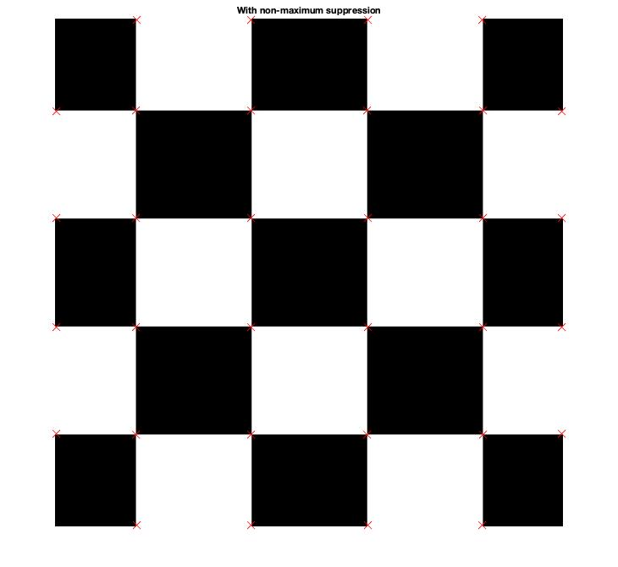

**Part C**

1. **Prepare a brighter version of the original image by adding a constant positive offset 100 to all pixel values.**

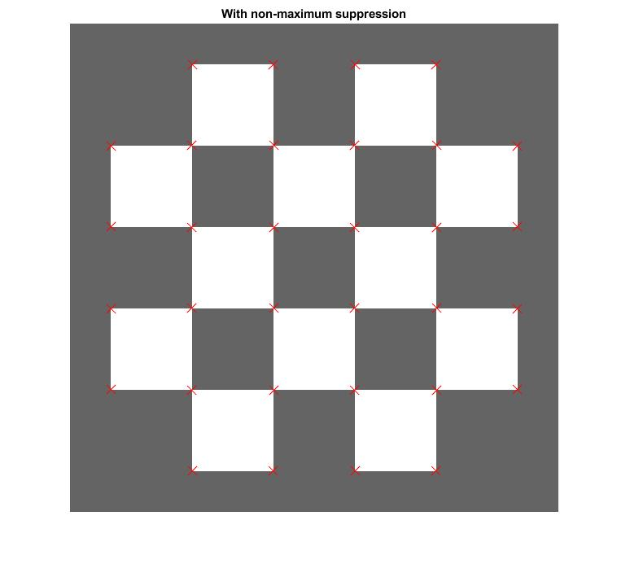

The left side image is the original image. The right side image is the fixed version. The corner detector works well on both images. All corners are detected correctly.

1. **Prepare a darker version of the original image by adding a constant negative offset -100 to all pixel values.**

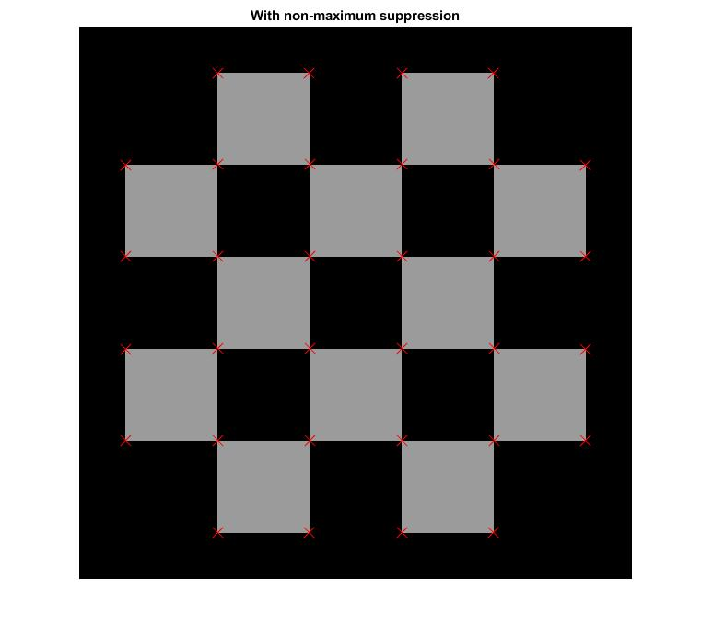

The left side image is the original image. The right side image is the fixed version. The corner detector works well on both images. All corners are detected correctly.

1. **Prepare a brighter version of the original image by multiplying a constant positive offset 10 to all pixel values.**

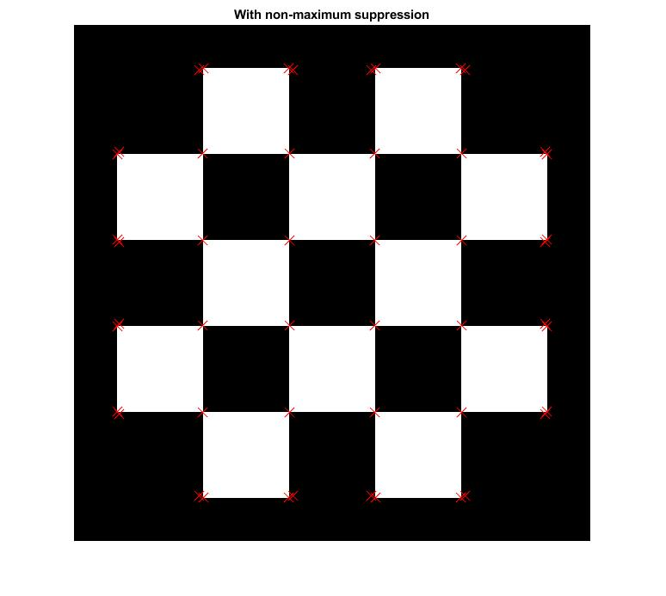

The left side image is the original image. The right side image is the fixed version. The corner detector correctly detected some corners which are located around the center of the image. The corners near the edge are multiply detected. In the original picture, it has 32 corners which are detected correctly, but in the fixed picture, the correct detected corners are 16. The percentage of matching features is 50%.

1. **Prepare a darker version of the original image by multiplying a constant negative offset 0.5 to all pixel values.**

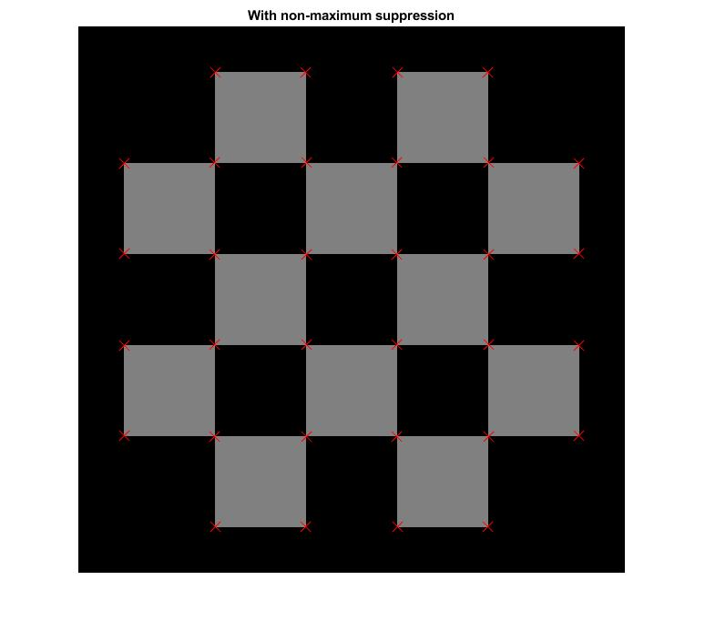

The left side image is the original image. The right side image is the fixed version. The corner detector works well on both images. All corners are detected correctly.

**Part D**

All results in this section under the same parameters’ condition. The variables values are:

Threshold = 0.6*10^10; w = 5 and suppression = true. Apply Gaussian noise to a same synthetic image.

**1. Standard (without the Gaussian noise)**

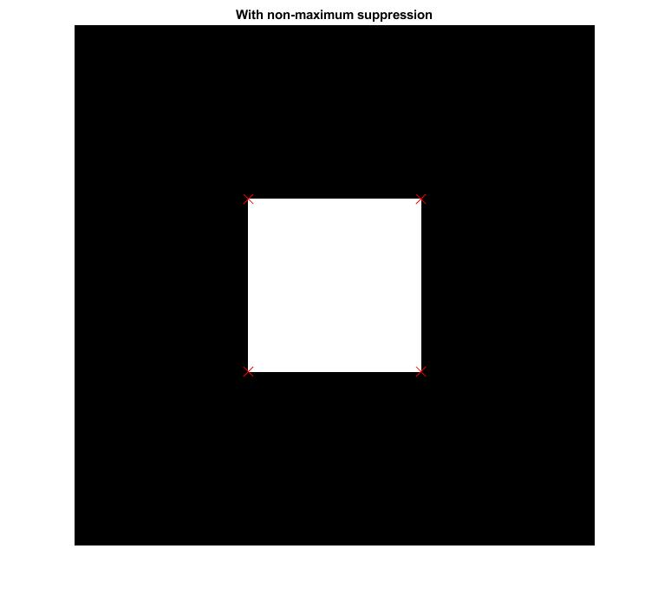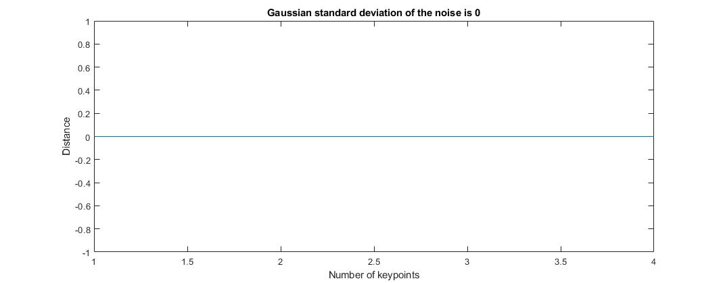

0 corners are missing and 0 corners are wrongly detected.

**2. With Gaussian standard deviation of noise is 25/256**

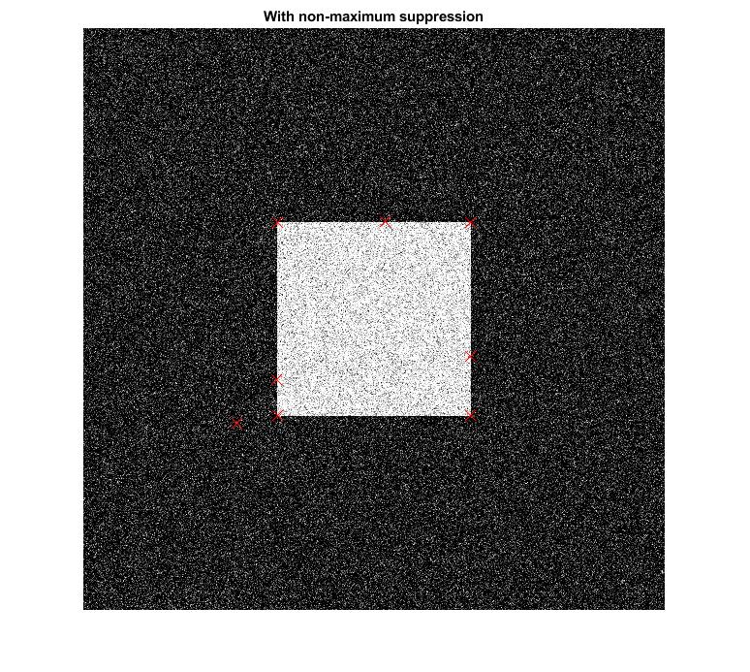

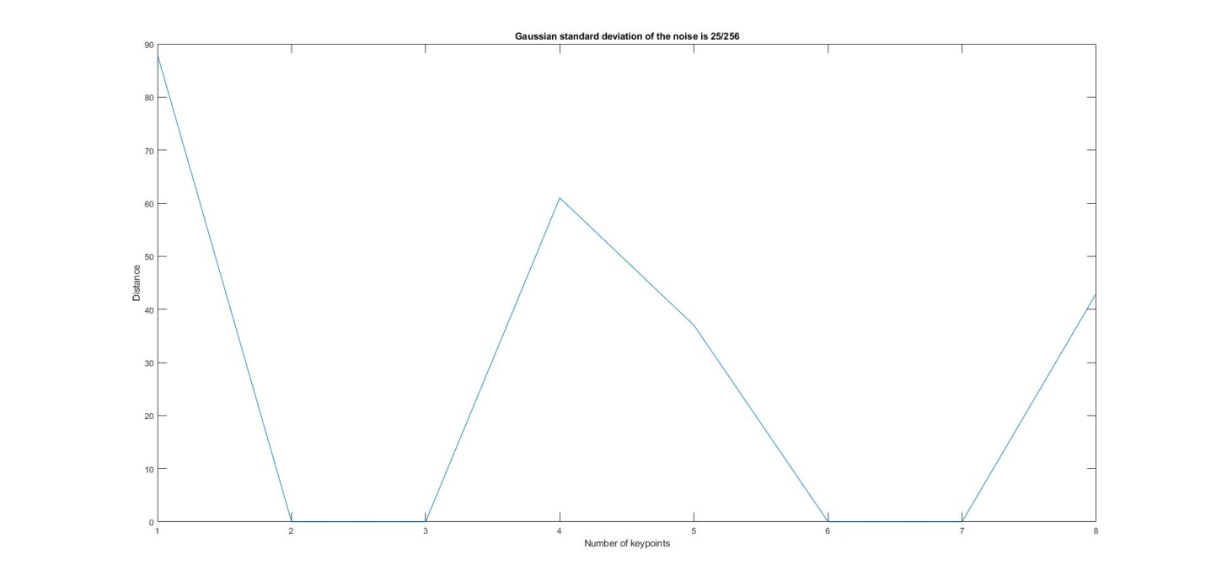

0 corners are missing and 4 corners are wrongly detected.

**3. With Gaussian standard deviation of noise is 50/256**

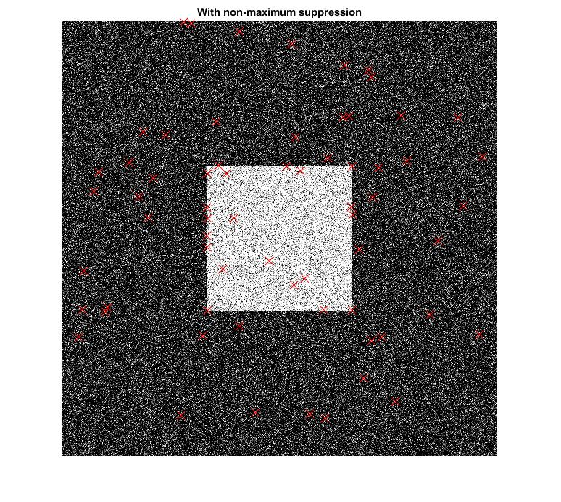

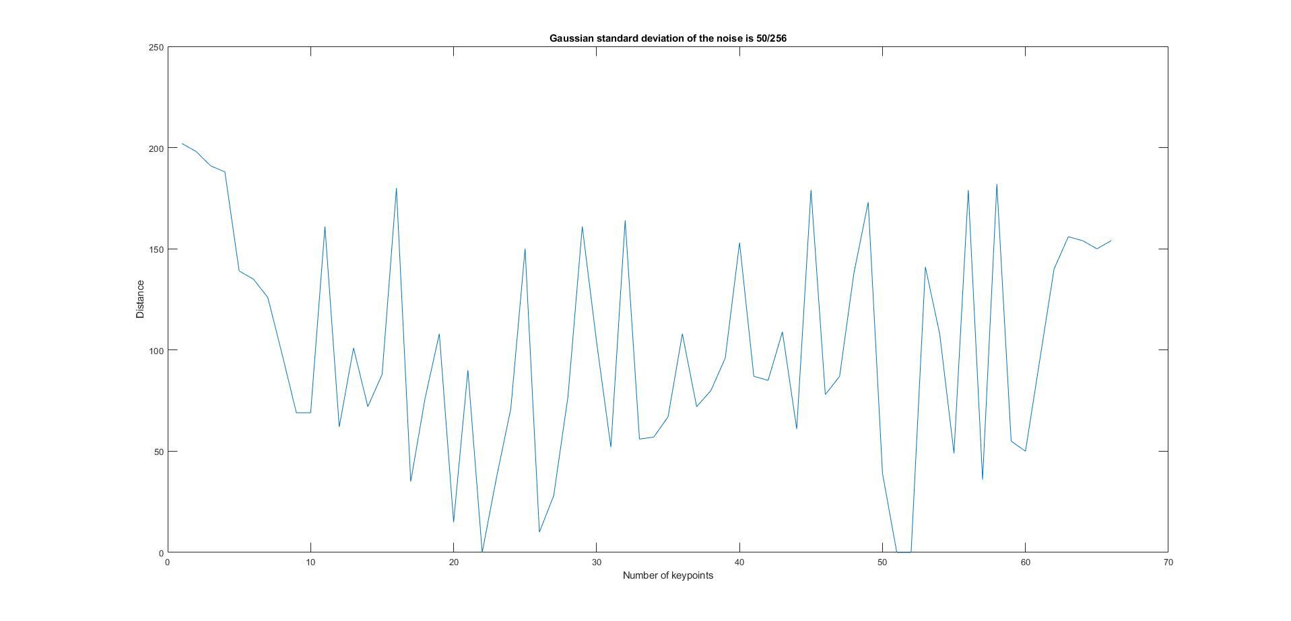

1 corners are missing and 63 corners are wrongly detected.

1. **With Gaussian standard deviation of noise is 100/256**

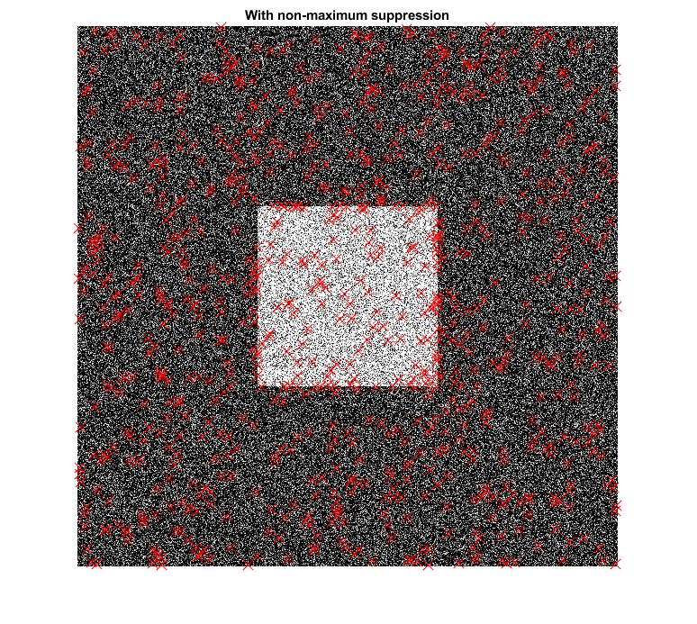

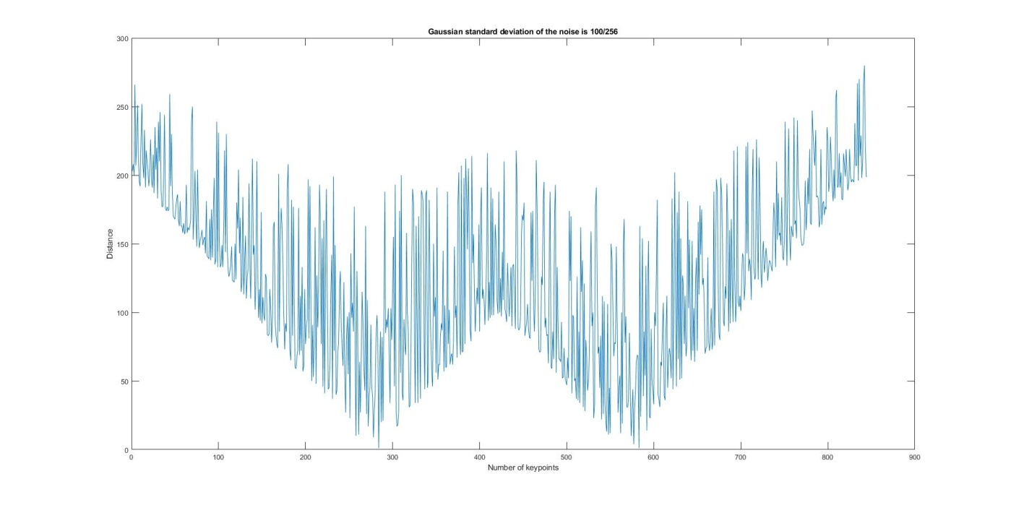

2 corners are missing and 843 corners are wrongly detected